Basic Scripting

11.1 Shell Scripts in a Nutshell
A shell script is a file of executable commands that has been stored in a text file. When the file is run, each command is executed. Shell scripts have access to all the commands of the shell, including logic. A script can therefore test for the presence of a file or look for particular output and change its behavior accordingly. You can build scripts to automate repetitive parts of your work, which frees your time and ensures consistency each time you use the script. For instance, if you run the same five commands every day, you can turn them into a shell script that reduces your work to one command.
Running a script can be done either by passing it as an argument to your shell or by running it directly:

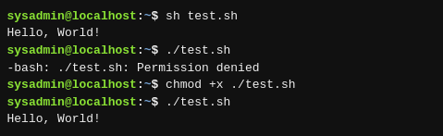

chmod is used to change the permissions of a file,

There are various shells with their own language syntax. Therefore, more complicated scripts will indicate a particular shell by specifying the absolute path to the interpreter as the first line, prefixed by #! as shown:
#!/bin/sh
echo "Hello, World!"
or
#!/bin/bash
echo "Hello, World!"
The two characters #! are traditionally called the hash and the bang respectively, which leads to the shortened form of “shebang” when they’re used at the beginning of a script.

11.2 Editing Shell Scripts
UNIX has many text editors. The merits of one over the other are often hotly debated. Two are specifically mentioned in the LPI Essentials syllabus: The GNU nano editor is a very simple editor well suited to editing small text files. The Visual Editor, vi, or its newer version, VI improved (vim), is a remarkably powerful editor but has a steep learning curve. We’ll focus on nano.
Type nano test.sh and you’ll see a screen similar to this:
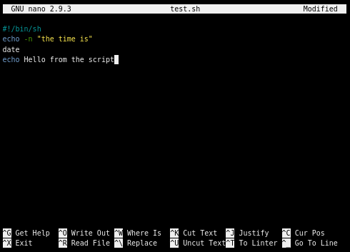

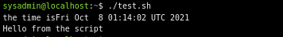

11.3 Scripting Basics

There are 3 topics you must become familiar with:
- Variables, which hold temporary information in the script
- Conditionals, which let you do different things based on tests you write
- Loops, which let you do the same thing over and over

11.3.1 Variables
Variables are a key part of any programming language. A very simple use of variables is shown here:
#!/bin/bash

ANIMAL="penguin"
echo "My favorite animal is a $ANIMAL"
After the shebang line is a directive to assign some text to a variable. The variable name is ANIMAL and the equals sign assigns the string penguin.
It is important that there are no spaces between the name of the variable, the equals sign, and the item to be assigned to the variable. If you have a space there, you will get an odd error such as “command not found”. Capitalizing the name of the variable is not necessary but it is a useful convention to separate variables from commands to be executed.

To access the contents of the variable, prefix it with a dollar sign. Here, we show a variable being assigned the contents of another variable!
#!/bin/bash

ANIMAL=penguin
SOMETHING=$ANIMAL
echo "My favorite animal is a $SOMETHING"

Another way to assign to a variable is to use the output of another command as the contents of the variable by enclosing the command in back ticks:
#!/bin/bash
CURRENT_DIRECTORY=`pwd`
echo "You are in $CURRENT_DIRECTORY"
This pattern is often used to process text. You might take text from one variable or an input file and pass it through another command like sed or awk to extract certain parts and keep the result in a variable. The sed command is used to edit streams (STDIN) and the awk command is used for scripting.

It is possible to get input from the user of your script and assign it to a variable through the read command:
#!/bin/bash

echo -n "What is your name? "
read NAME
echo "Hello $NAME!"
There are some special variables in addition to the ones you set. You can pass arguments to your script:
#!/bin/bash
echo "Hello $1"
A dollar $ sign followed by a number N corresponds to the Nth argument passed to the script. If you call the example above with ./test.sh World the output will be Hello World. The $0 variable contains the name of the script itself.

After a program runs, be it a binary or a script, it returns an exit code which is an integer between 0 and 255. You can test this through the $? variable to see if the previous command completed successfully.
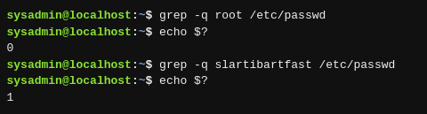

This information can be used in a conditional to perform an action based on the output of another command.

Likewise you can set the exit code of your own script with the exit command:
#!/bin/bash
# Something bad happened!
Exit 1

11.3.2 Conditionals
A basic if statement looks like this:
if somecommand; then
# do this if somecommand has an exit code of 0
fi
The next example will run “somecommand” (actually, everything up to the semicolon) and if the exit code is 0 then the contents up until the closing fi will be run.
#!/bin/bash

if grep -q root /etc/passwd; then
echo root is in the password file
else
echo root is missing from the password file
fi

The test command gives you easy access to comparison and file test operators. For example:
Command | Description
test –f /dev/ttyS0 | 0 if the file exists
test ! –f /dev/ttyS0 | 0 if the file doesn’t exist
test –d /tmp | 0 if the directory exists
test –x `which ls` | substitute the location of ls then test if the user can execute
test 1 –eq 1 | 0 if numeric comparison succeeds
test ! 1 –eq 1 | NOT – 0 if the comparison fails
test 1 –ne 1 | Easier, test for numeric inequality
test “a” = “a” | 0 if the string comparison succeeds
test “a” != “a” | 0 if the strings are different
test 1 –eq 1 –o 2 –eq 2 | -o is OR: either can be the same
test 1 –eq 1 –a 2 –eq 2 | -a is AND: both must be the same

test is fairly verbose for a command that gets used so frequently, so there is an alias for it called [ (left square bracket). If you enclose your conditions in square brackets, it’s the same as running test. So, these statements are identical.
if test –f /tmp/foo; then
if [ -f /tmp/foo]; then
The if statement has a final form that lets you do multiple comparisons at one time using elif (short for else if).
#!/bin/bash

if [ "$1" = "hello" ]; then
echo "hello yourself"
elif [ "$1" = "goodbye" ]; then
echo "nice to have met you"
echo "I hope to see you again"
else
echo "I didn't understand that"
fi

The if/elif/else tests can become quite verbose and complicated. The case statement provides a different way of making multiple tests easier.
#!/bin/bash

case "$1" in
hello|hi)
echo "hello yourself"
;;
goodbye)
echo "nice to have met you"
echo "I hope to see you again"
;;
*)
echo "I didn't understand that"
esac

11.3.3 Loops
Loops allow code to be executed repeatedly. There are two main loops in shell scripts: the for loop and the while loop.
for loops are used when you have a finite collection over which you want to iterate, such as a list of files, or a list of server names:
#!/bin/bash

SERVERS="servera serverb serverc"
for S in $SERVERS; do
echo "Doing something to $S"
done
The second loop uses a * which is a file glob. This gets expanded by the shell to all the files in the current directory.

/bin/bash
for S in *; do
echo "Doing something to $S"
done
The other type of loop, a while loop, operates on a list of unknown size. Its job is to keep running and on each iteration perform a test to see if it should run another time. You can think of it as “while some condition is true, do stuff.”

#!/bin/bash
i=0
while [ $i -lt 10 ]; do
echo $i
i=$(( $i + 1))
done
echo “Done counting”

